Project - Pixogram

## Architectural details

1. Backend is developed using – Spring boot, JPA , MySql database
2. Frontend using Angular 8, Bootstrap 4 and node - version 12.
3. Micro service namely UserMicroservice, ActivitiesMicroservice and MediaMicroservice connects 3 different schemas pixogramuser, pixogramactivites and pixogrammedia for user, activities and media related operation respectively.
4. Backend mS Details:
   * 1. User Microservice does –
        1. user registration
        2. Authentication
        3. Account Update
     2. Activities Microservice does –
5. Blocking/Unblocking
6. Following/Unfollowing.
   * 1. Media Microservice is responsible for –
7. Media upload (Single and Multi)
8. Like/Unlike
9. Comment
10. Media details.
11. Database snapshot:

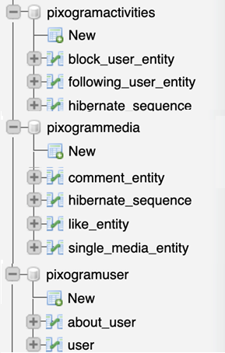

## Home Page:

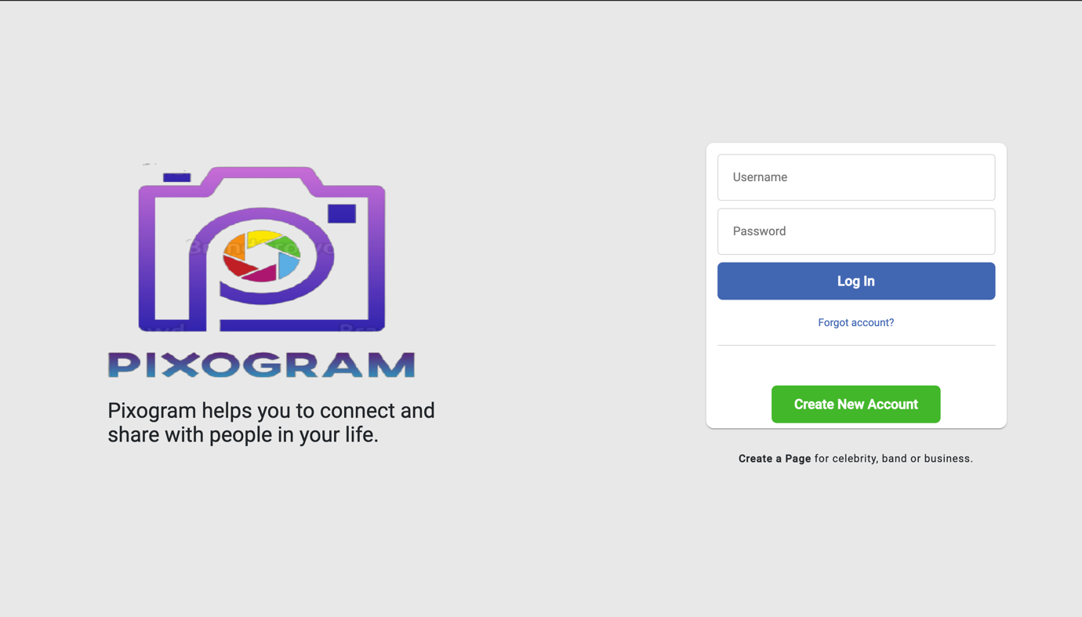

### Registration Page:

User Can Register by clicking Create New Account

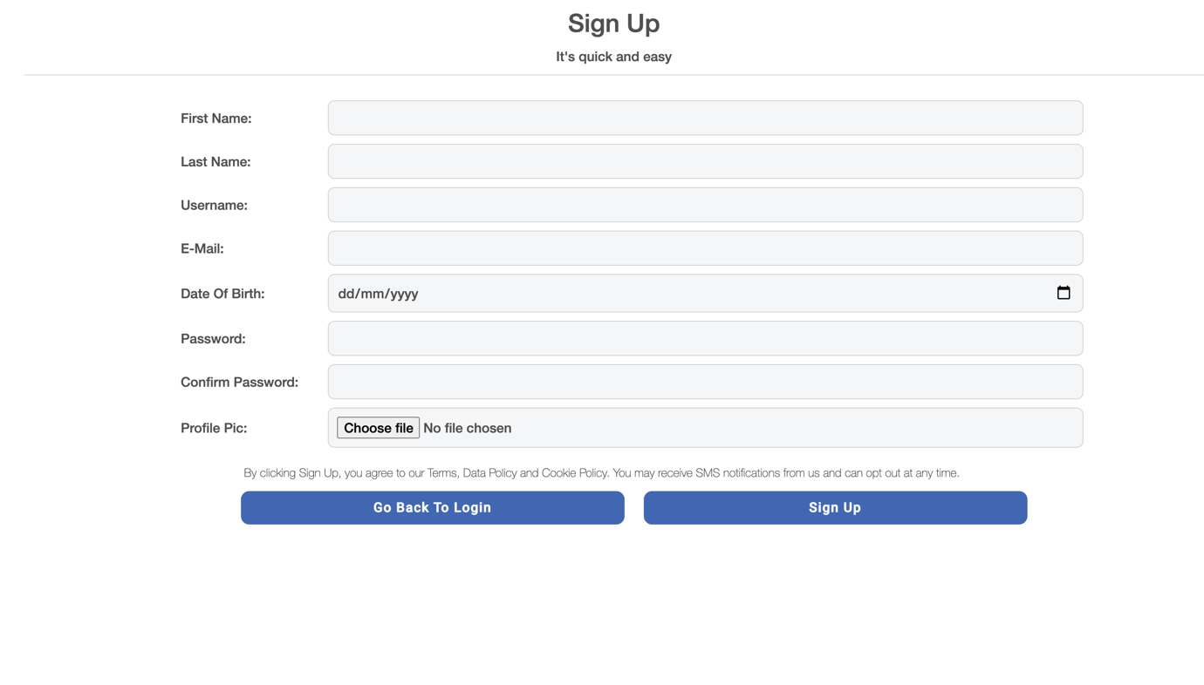

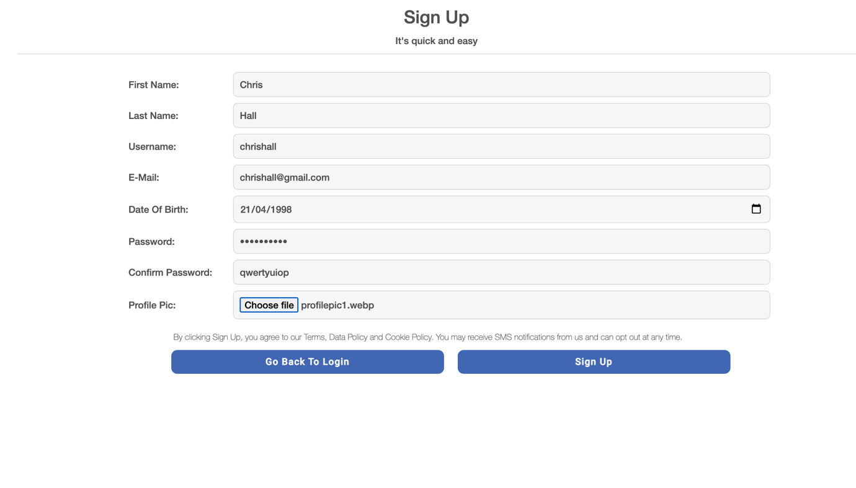

Image showing user registration details in the database.

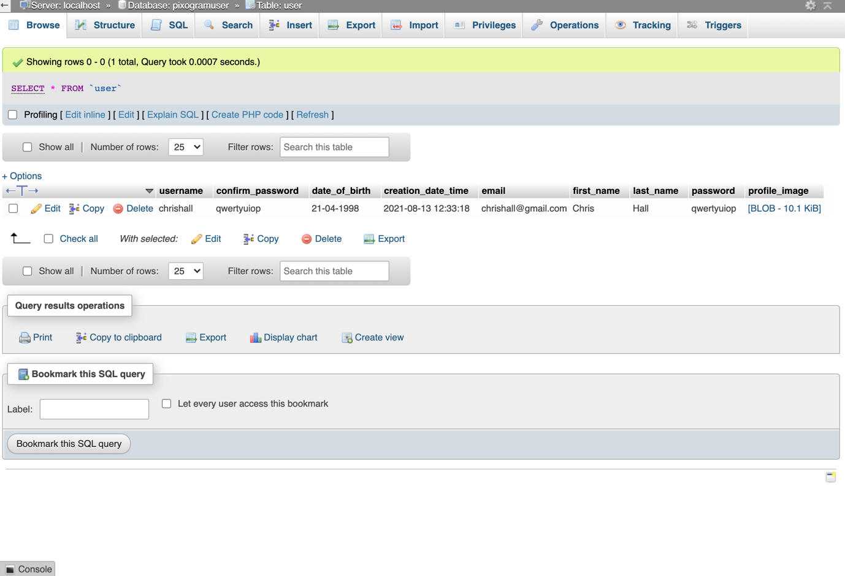

Image showing login screen with Invalid credentials.

## User Dashboard:

Upon Successful Login, Home Page showing the posts user has uploaded along with the comments.

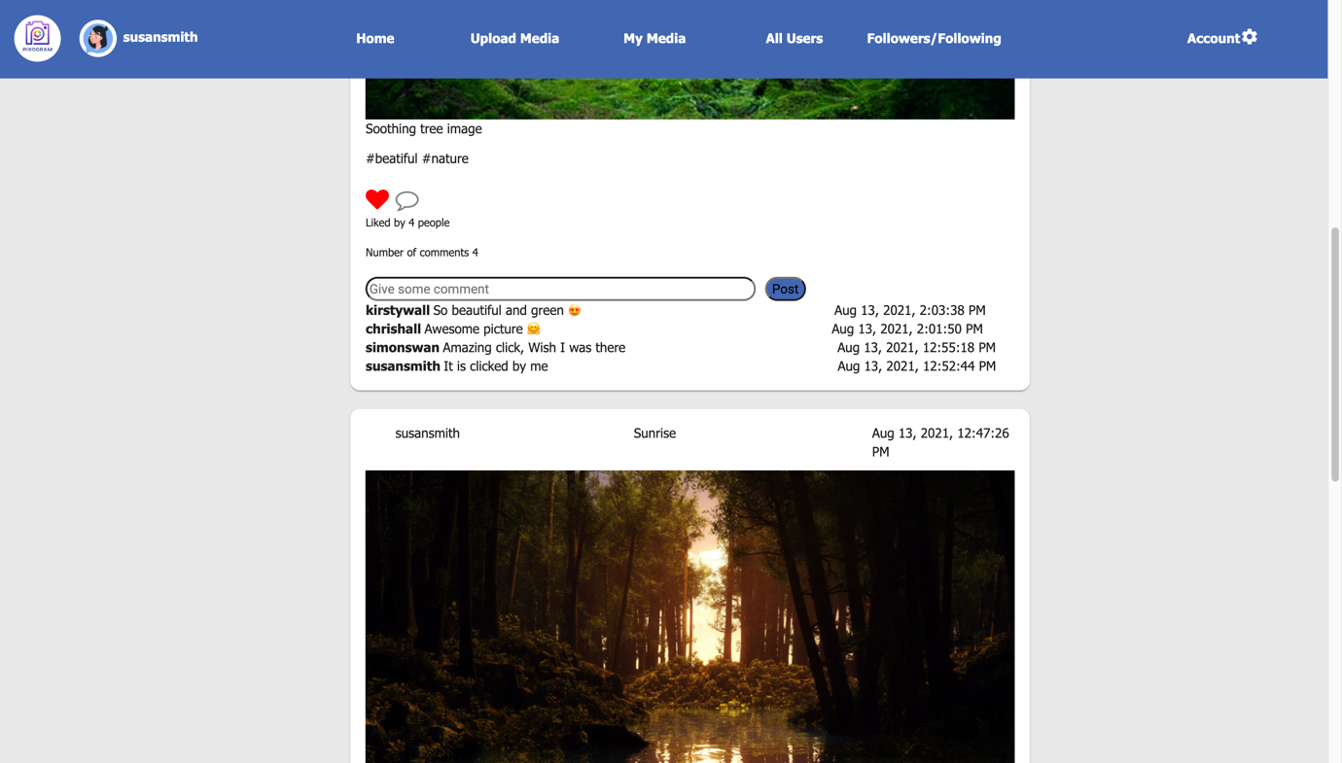

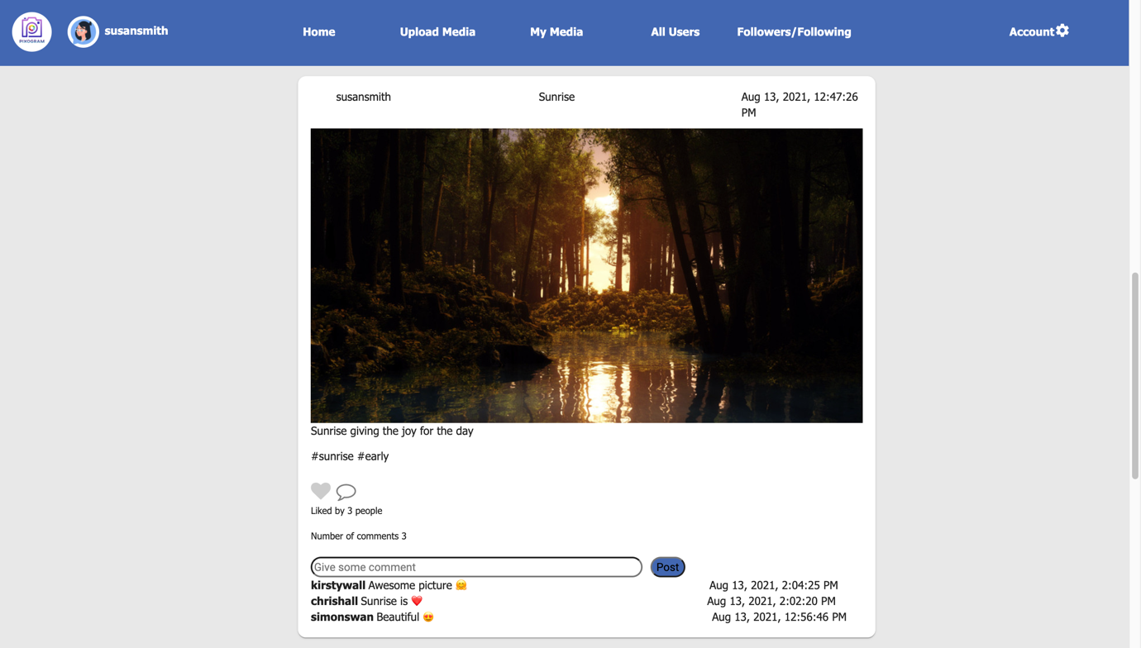

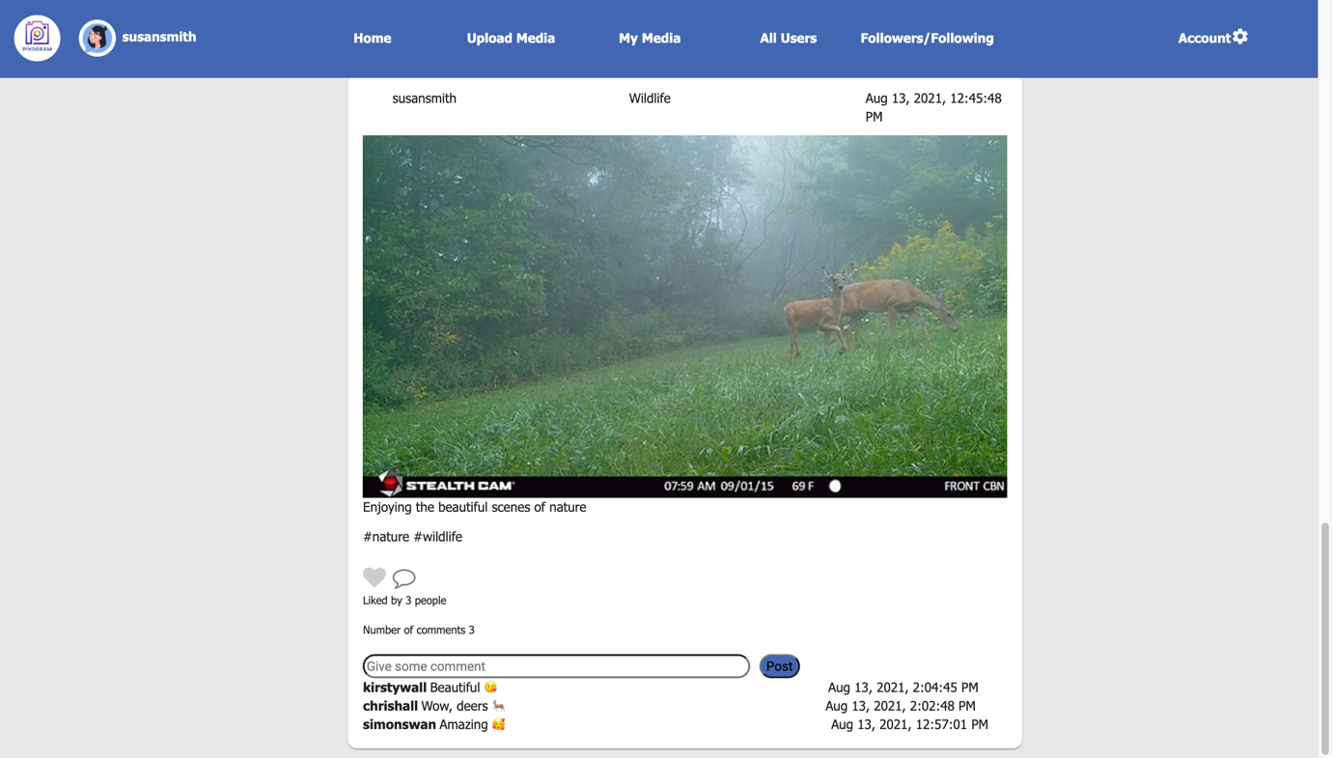

## All User tab :

Registered User shown as below: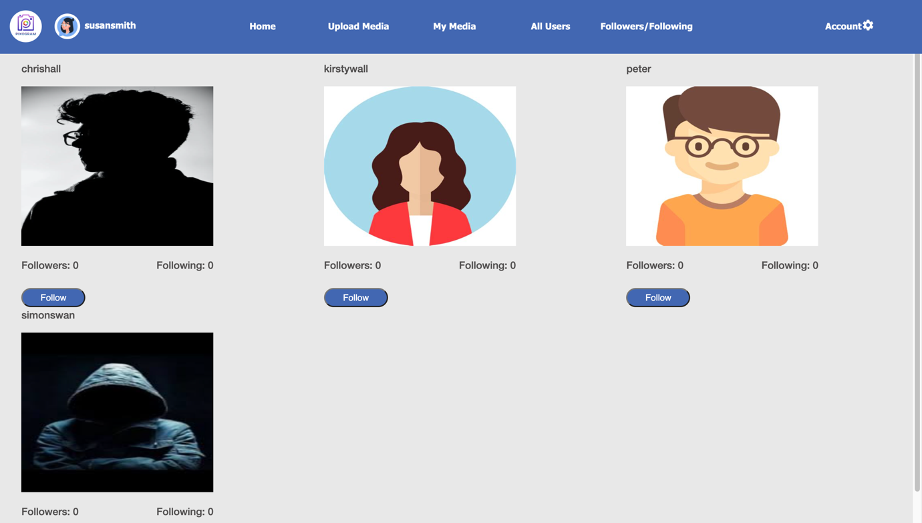

Image showing Followers and Following under all users tab.

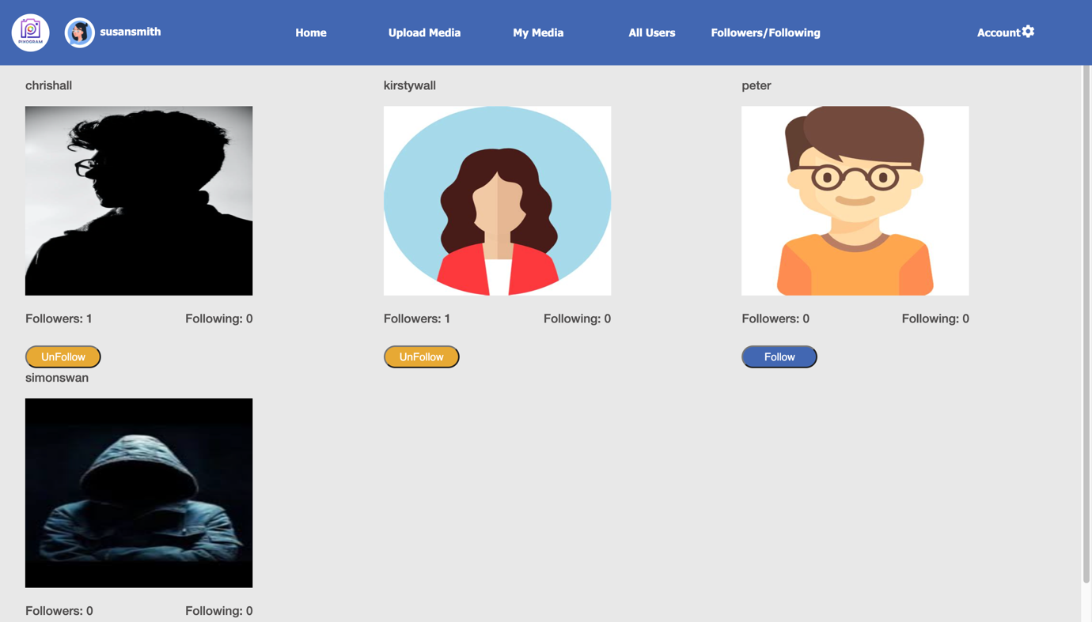

## Upload Media

### Single Media Upload

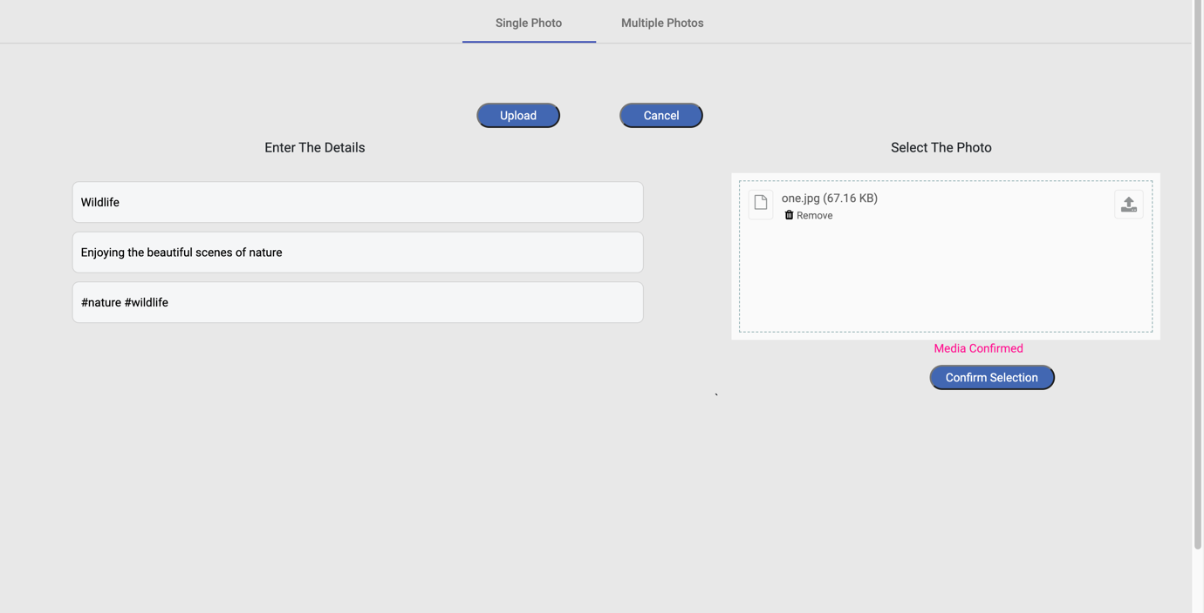

### Multiple Media Upload

## My Media

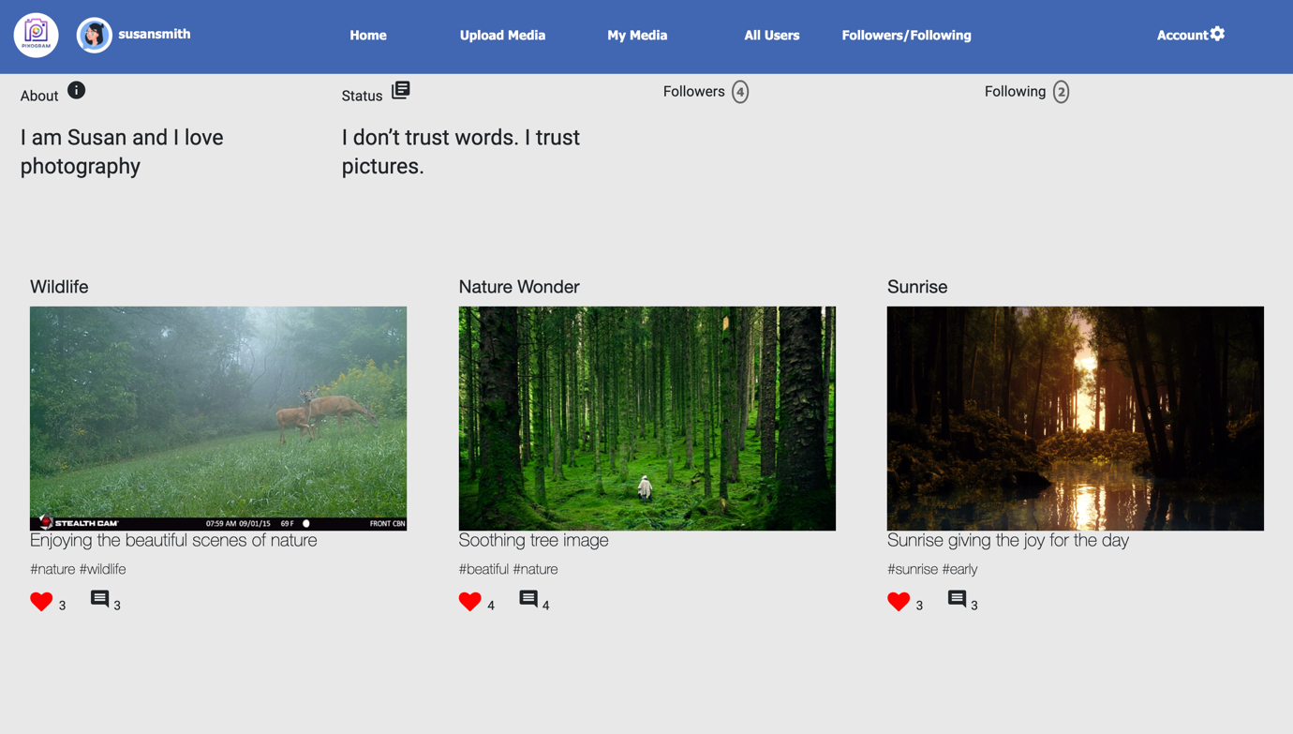

Image showing details of a specific post

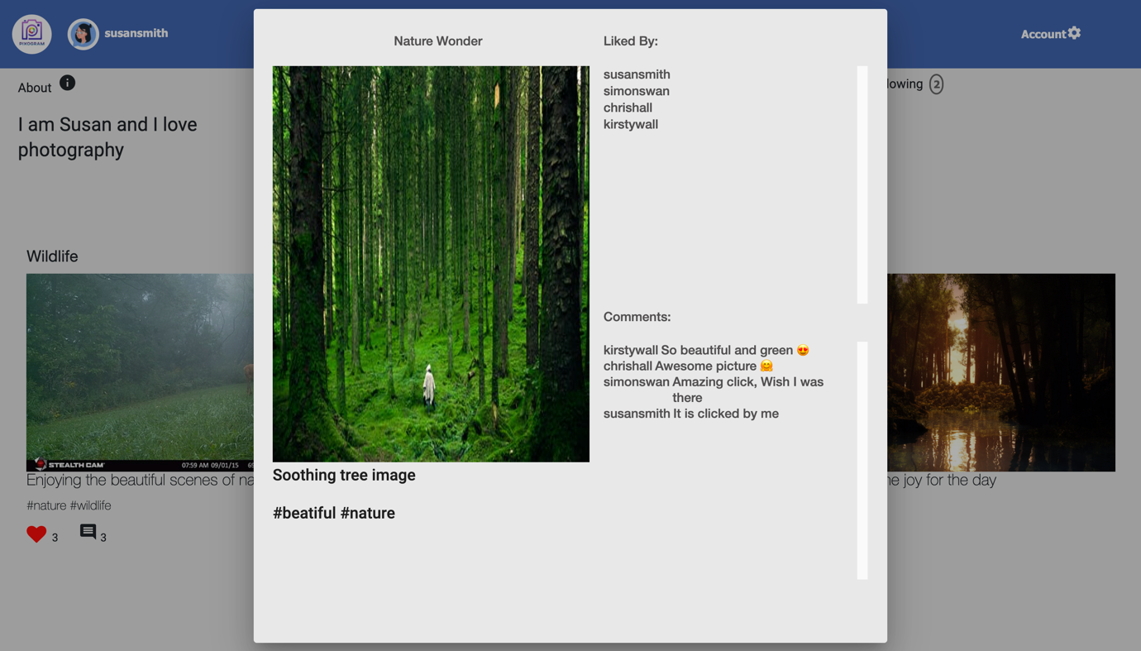

## Followers/Following

Image showing Followers and Following

### Followers

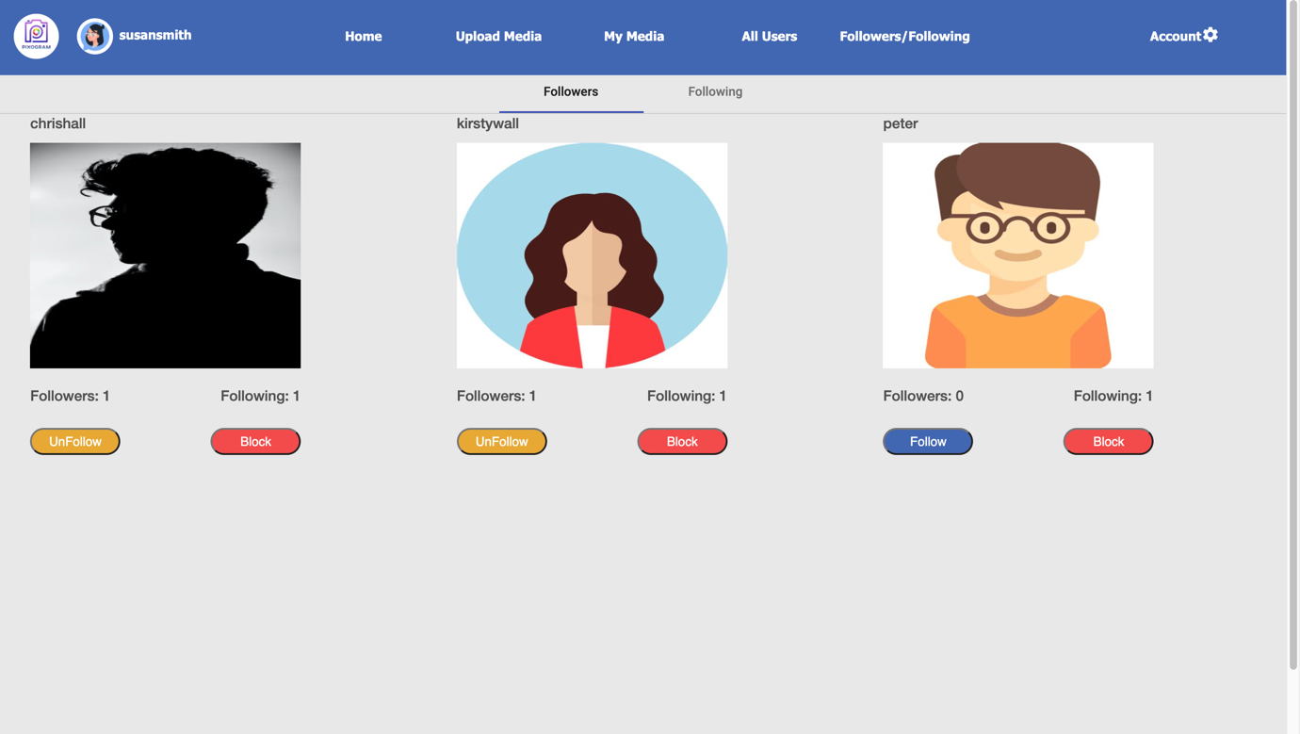

### Following

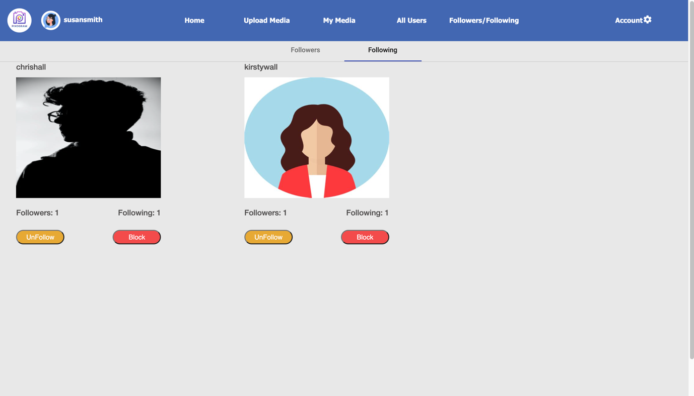

## Account Management

### News Feed

Image showing all activities logs.

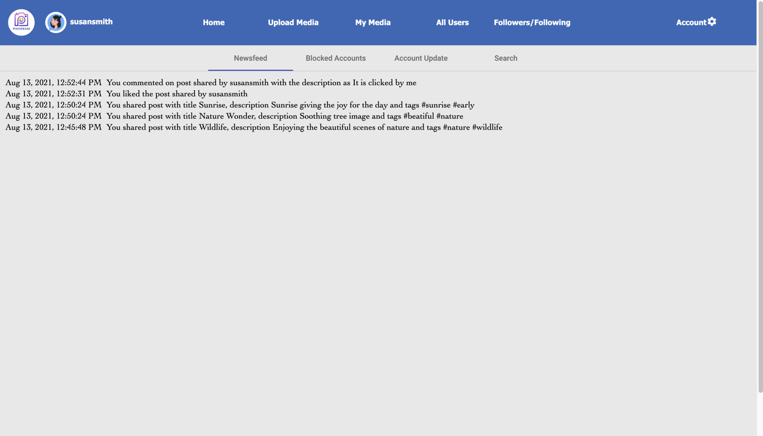

### Blocked Accounts

Image showing Blocked Accounts: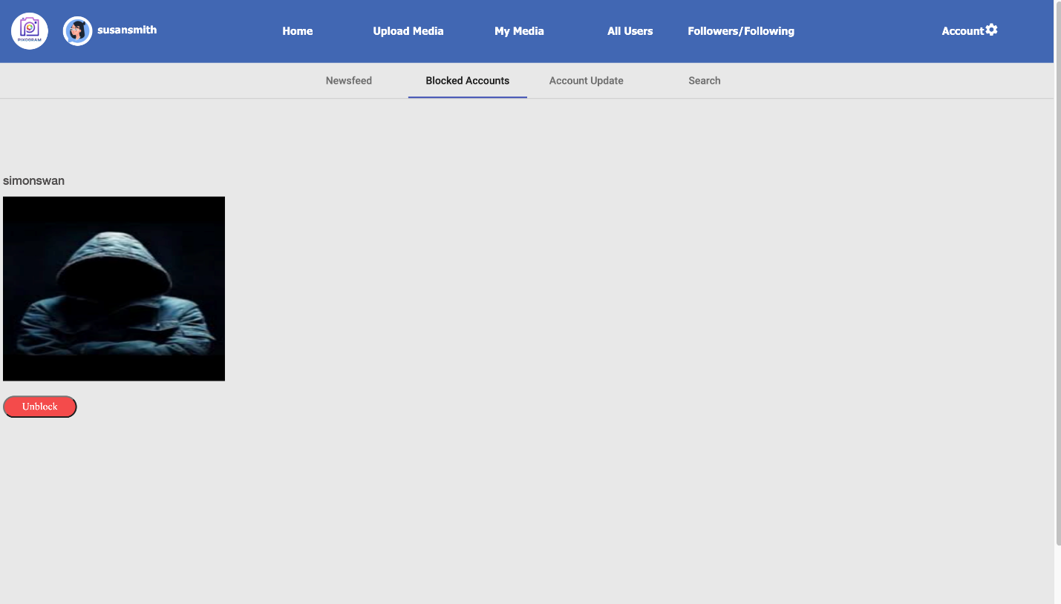

### Account Update

Image showing Account Update such as status/about me.

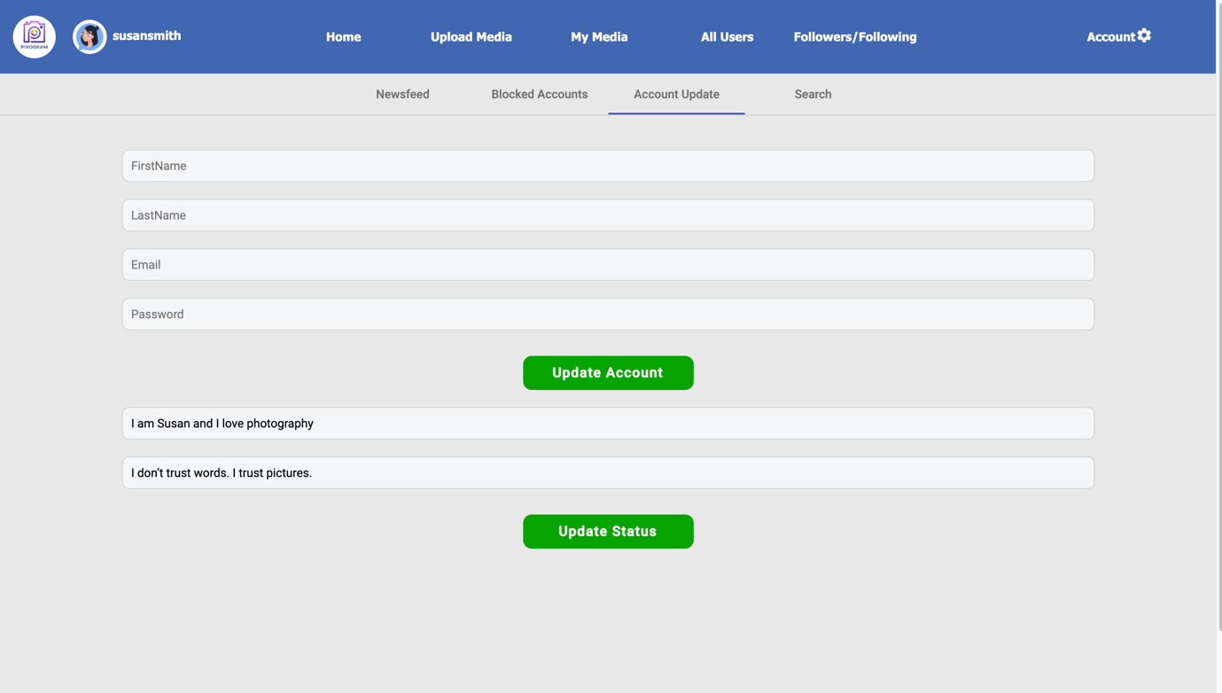

### Search Tab

Image showing search results when typed – ‘n’ both from tag and user section

